**RECODING VARIABLES IN SPSS**

**Assignment Number 3**

Register Number: 1740256

**Date:** 04/12/2017

--------------------------------------------------------------------------------------------

Recoding variables is done to code any variable in the way we want it for analysis. Recoding is of 2 types –

1. Recoding into the same variable
2. Recoding into different variables.

Recoding into the same variable changes the original variable and is not preferred. This is because researchers want to retain the original value for cross checking and other purposes.   
Thus, we will be using recoding into different variables in all the exercises.

**Question 1**

**Aim -**  To recode a variable into a new variable.

**Procedure -**

1. Open the required file in SPSS.
2. Go to transform and select recode into different variable.
3. Choose the variable which has to be recoded and drag to the right - hand box.
4. Under the output variable name, enter the new name and press change.
5. Click on old and new values and enter the values of the new variable.
6. Click add and then continue.
7. We observe that a new variable has been introduced in the data set.

**Calculations –**

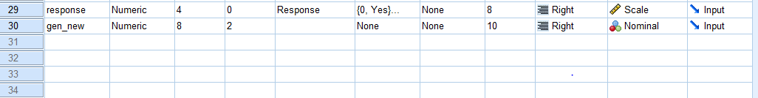

**Conclusions –**

The above screenshot has gender recoded as gen_new.

------------------------------------------------------------------------------------------------------------------

**Question 2**

**Aim –** The data given below shows the scores of 20 students in a final exam. Enter the data in SPSS, compute the required descriptive statistics and recode the data as follows.  
A – if score is between 80 and 100  
B - for 60 to 80  
C – for 50 to 60  
F – below 50

**Procedure –**

1. Open the required file in SPSS.
2. Go to transform and select recode into different variable.
3. Choose the variable which has to be recoded and drag to the right - hand box.
4. Under the output variable name, enter the new name and press change.
5. Click on old and new values and enter the values of the new variable.
6. If the new variables are a character, click the check which has strings.
7. Click add and then continue.
8. We observe that a new variable has been introduced in the data set.

**Calculations –**

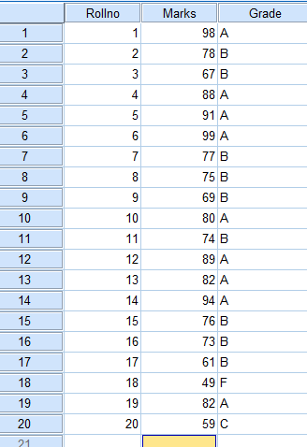 **Conclusions –**

The above screenshot has marks recoded as grade.

------------------------------------------------------------------------------------------------------------------